Ezra Muir

September 11, 2022

Question 42

DROP TABLE IF EXISTS Employee_personal_new;

CREATE TABLE Employee_personal_new (

EMPID INT PRIMARY KEY NOT NULL,

NAME VARCHAR(50) NOT NULL,

PLACE VARCHAR(50) NOT NULL,

GENDER VARCHAR(50) NOT NULL,

AVAILABLE VARCHAR(50) NOT NULL,

PHNO VARCHAR(50) NOT NULL,

DEPARTMENT VARCHAR(50) NOT NULL

);

-- Insert into tables

INSERT INTO

Employee_personal_new

(EMPID, NAME, PLACE, GENDER, AVAILABLE, PHNO, DEPARTMENT)

VALUES

(001, 'Shippy', 'Kingston', 'Male', 'Yes', '(876) 987-8346', 'S/W Engg-A'),

(002, 'Priya', 'Montego Bay', 'Male', 'No', '(876) 785-6346', 'S/W Engg-C'),

(003, 'Alanzo', 'New Delhi', 'Male', 'Yes', '(876) 864-5346', 'S/W Engg'),

(004, 'Punitha', 'Saint James Parish', 'Female', 'Yes', '(876) 879-5346', 'S/W Engg-C'),

(005, 'Grant', 'Chennai', 'Male', 'No', '(876) 956-8346', 'S/W Engg-K'),

(006, 'Olando', 'Portmore', 'Male', 'Yes', '(876) 849-4346', 'S/W Engg'),

(007, 'Camille', 'Coimbatore', 'Female', 'No', '(876) 987-5346', 'S/W Engg-B'),

(008, 'Donald', 'Udumalper', 'Male', 'No', '(876) 895-4346', 'S/W Engg');

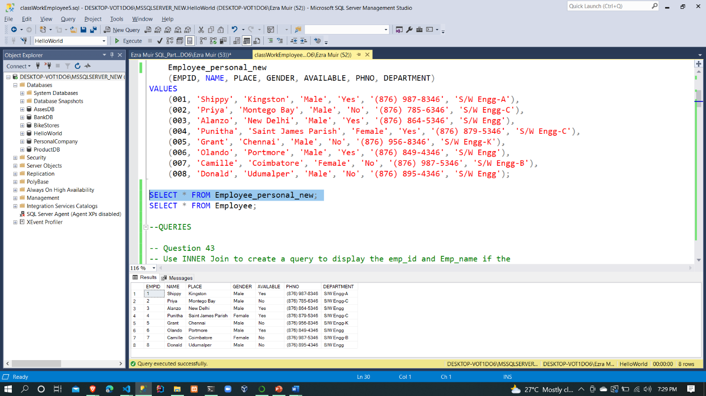

Question 43

SELECT

epn.EMPID 'Employee ID',

epn.NAME 'Employee Name'

FROM

Employee e

INNER JOIN Employee_personal_new epn

ON e.EMPID = epn.EMPID AND e.DEPARTMENT = epn.DEPARTMENT

WHERE epn.DEPARTMENT = 'S/W Engg' AND e.DEPARTMENT = 'S/W Engg'

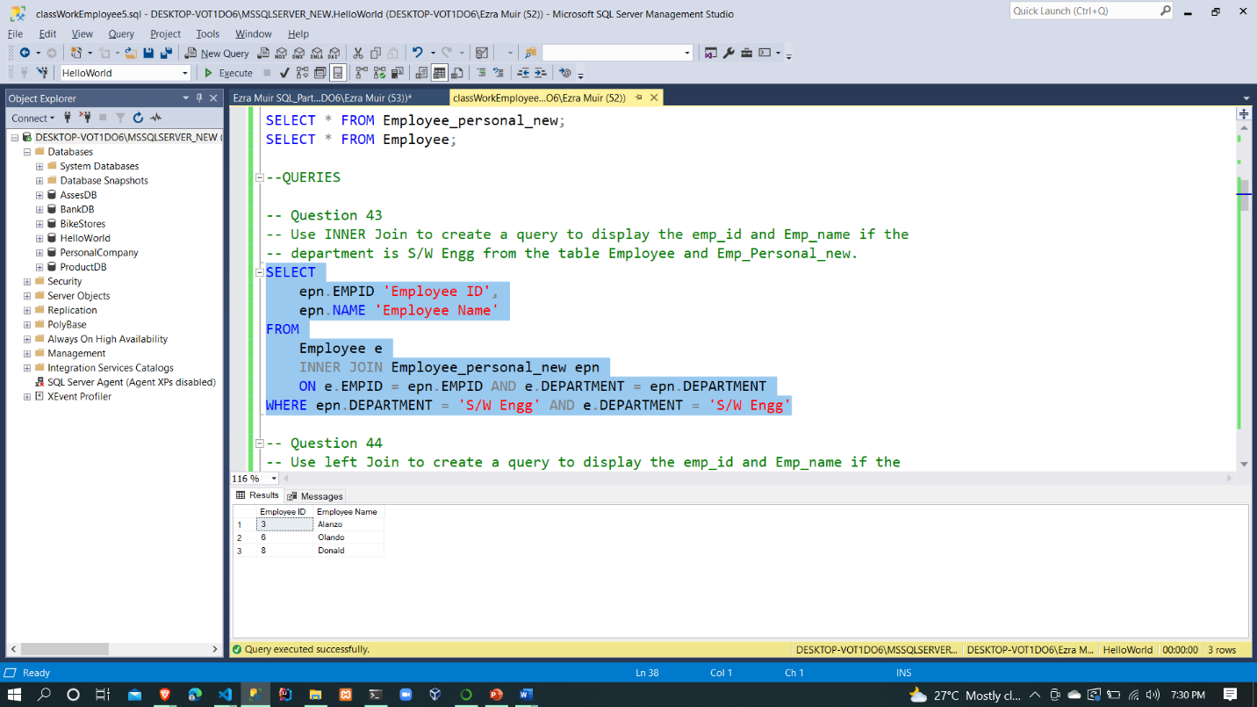

Question 44

SELECT

epn.EMPID 'Employee ID',

epn.NAME 'Employee Name'

FROM

Employee e

LEFT JOIN Employee_personal_new epn

ON e.EMPID = epn.EMPID AND e.DEPARTMENT = epn.DEPARTMENT

WHERE e.DEPARTMENT = 'S/W Engg'

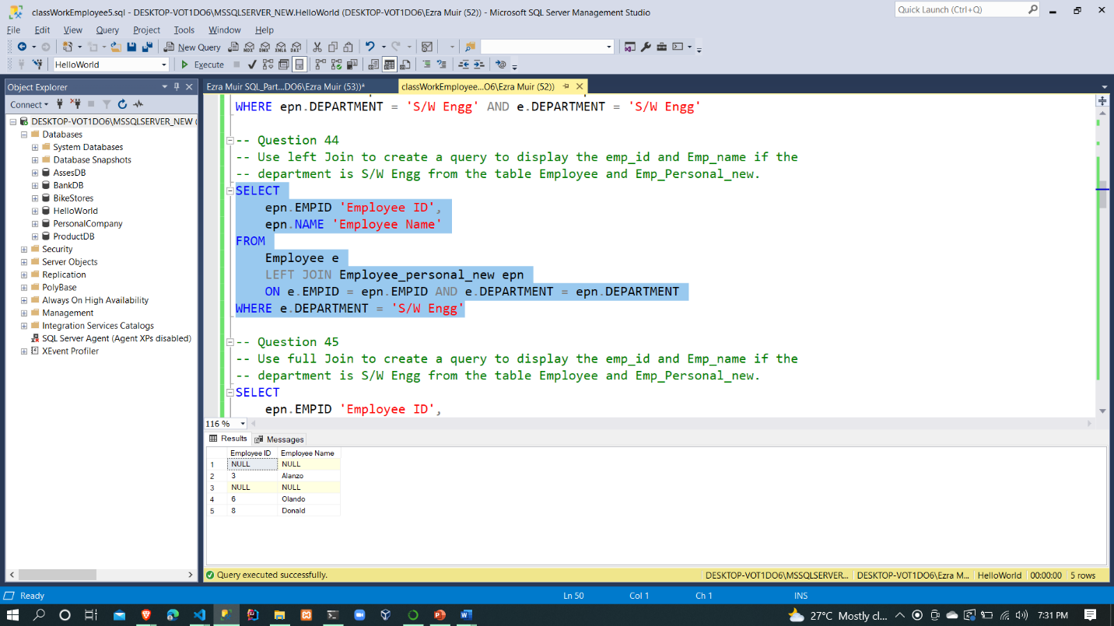

Question 45

SELECT

epn.EMPID 'Employee ID',

epn.NAME 'Employee Name'

FROM

Employee e

FULL OUTER JOIN Employee_personal_new epn

ON e.EMPID = epn.EMPID AND e.DEPARTMENT = epn.DEPARTMENT

WHERE epn.DEPARTMENT = 'S/W Engg' OR e.DEPARTMENT = 'S/W Engg'

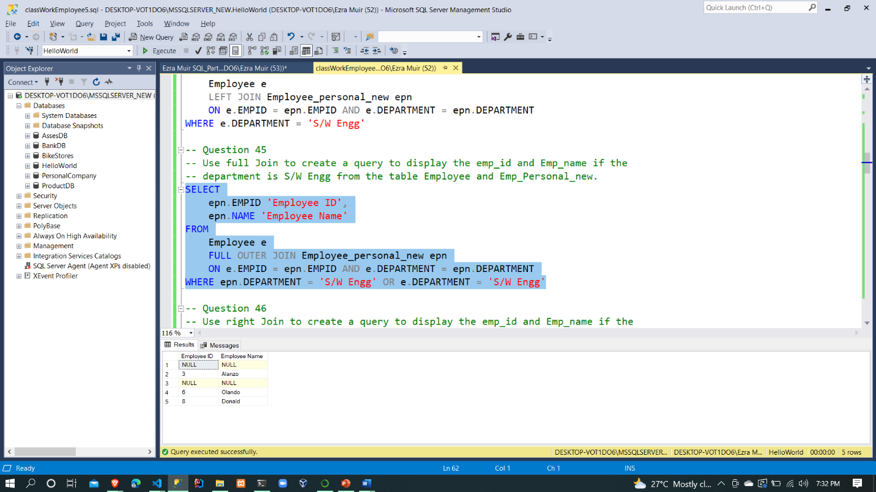

Question 46

SELECT

epn.EMPID 'Employee ID',

epn.NAME 'Employee Name'

FROM

Employee e

INNER JOIN Employee_personal_new epn

ON e.EMPID = epn.EMPID AND e.DEPARTMENT = epn.DEPARTMENT

WHERE epn.DEPARTMENT = 'S/W Engg'

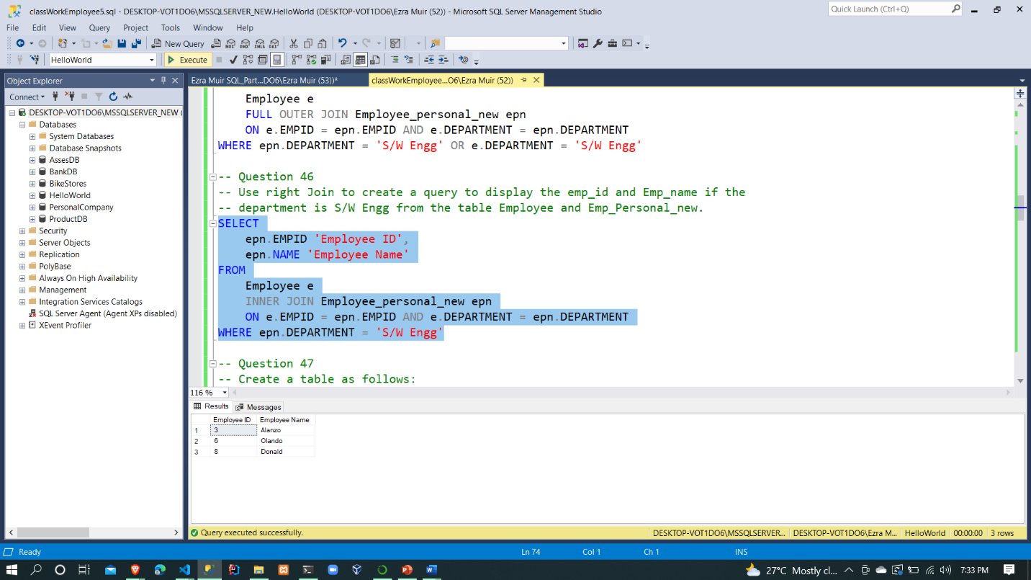

Question 47

CREATE TABLE table_1 (

id INT IDENTITY(1,1) PRIMARY KEY,

indian_name VARCHAR(25),

jamaican_name VARCHAR(25),

age INT

);

CREATE TABLE table_2 (

id INT IDENTITY(1,1) PRIMARY KEY,

name VARCHAR(25),

city VARCHAR(25),

age INT

);

-- INSERT INTO Tables

INSERT INTO table_1

(indian_name, jamaican_name, age)

VALUES

('Prahan', 'Shippy', 19),

('Aavani', 'Christopher', 18),

('Nemi', 'Alanzo', 19),

('Exhil', 'Ezra', 20),

('Raksha', 'Grant', 20);

INSERT INTO table_2

(name, city, age)

VALUES

('Prahan', 'New Delhi', 19),

('Kiruthi', 'Kingston', 19),

('Nemi', 'Glassgow', 19),

('Kavitha', 'Paris', 20),

('Ramya', 'Chennai', 20);

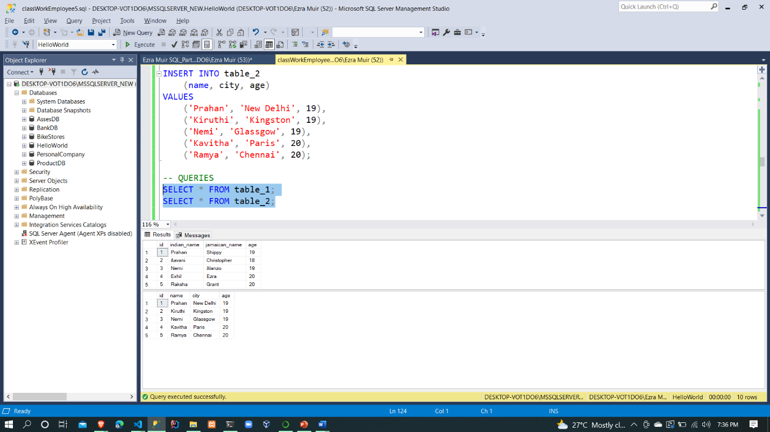

Question 48

SELECT

t1.indian_name 'Indian Name',

t2.city 'City Name'

FROM table_1 t1

INNER JOIN table_2 t2 ON t1.id = t2.id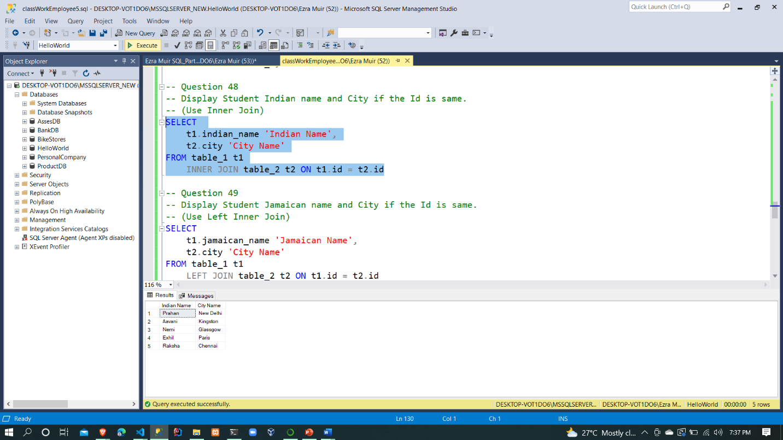

Question 49

SELECT

t1.jamaican_name 'Jamaican Name',

t2.city 'City Name'

FROM table_1 t1

LEFT JOIN table_2 t2 ON t1.id = t2.id

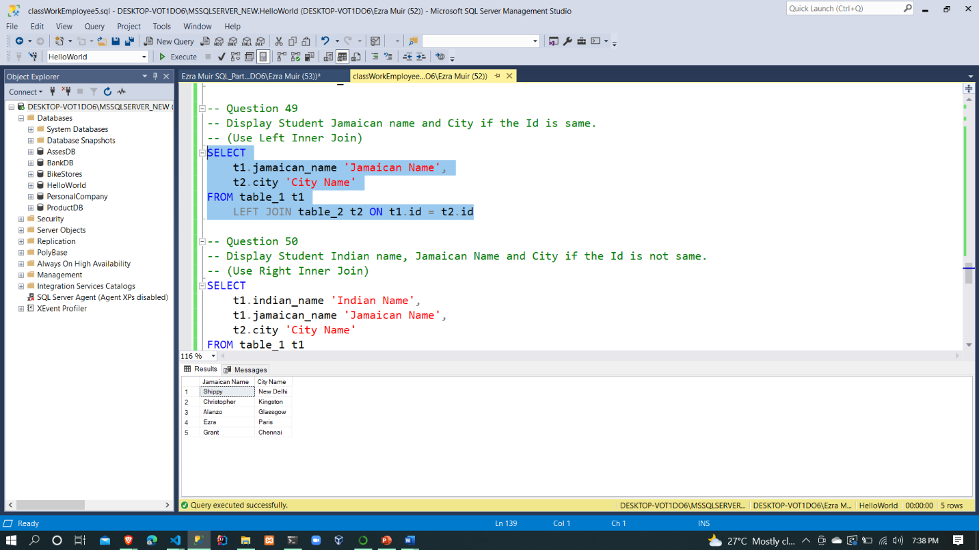

Question 50

SELECT

t1.indian_name 'Indian Name',

t1.jamaican_name 'Jamaican Name',

t2.city 'City Name'

FROM table_1 t1

RIGHT JOIN table_2 t2 ON t1.id <> t2.id

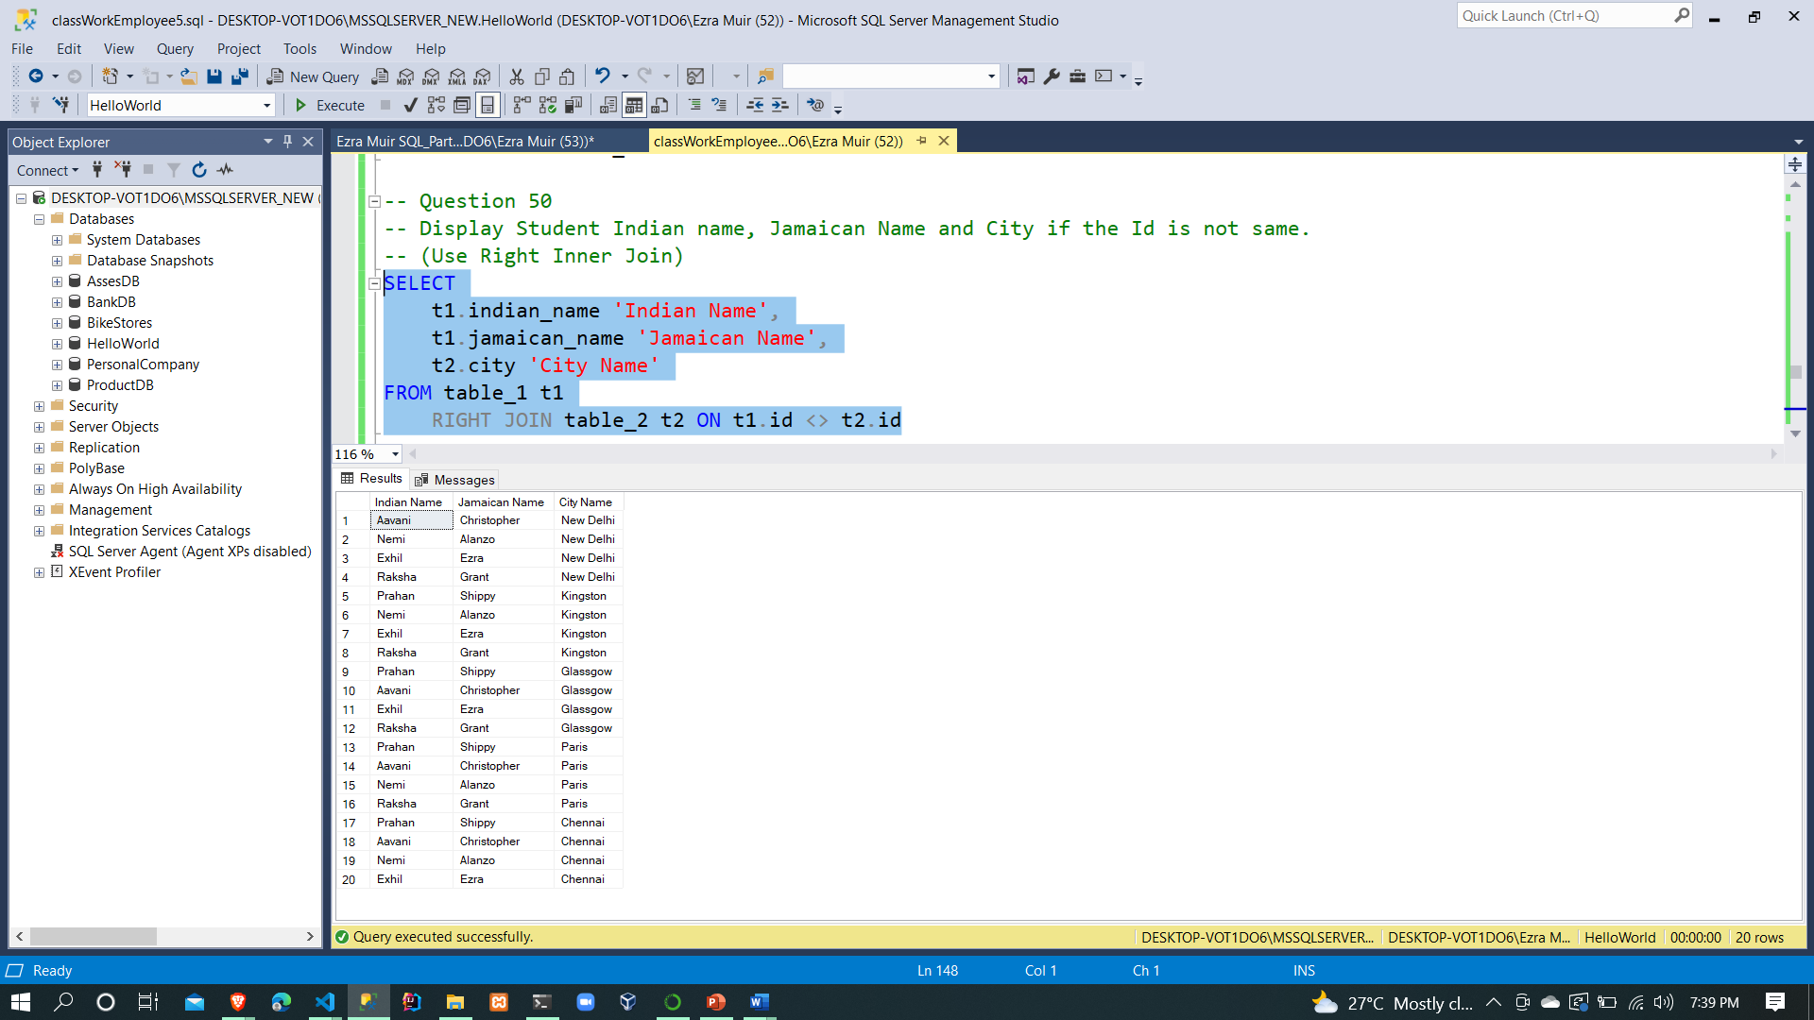

Question 51

SELECT

t1.jamaican_name 'Jamaican Name',

t2.age 'Age',

t2.city 'City Name'

FROM table_1 t1

RIGHT JOIN table_2 t2 ON t1.age = t2.age

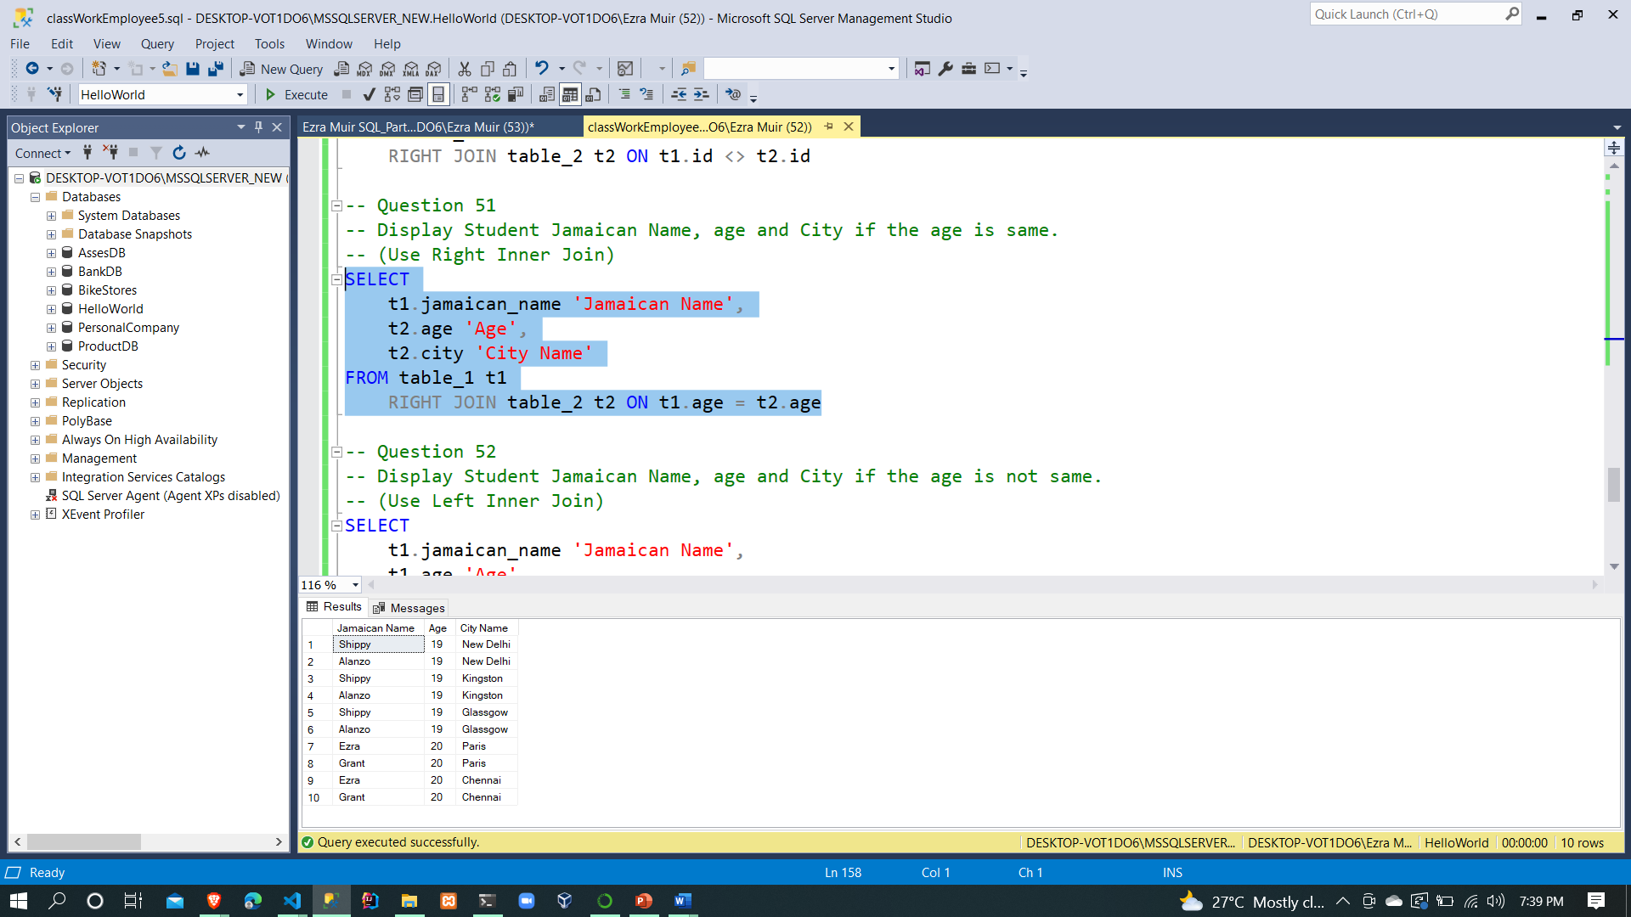

Question 52

SELECT

t1.jamaican_name 'Jamaican Name',

t1.age 'Age',

t2.city 'City Name'

FROM table_1 t1

LEFT JOIN table_2 t2 ON t1.age <> t2.age

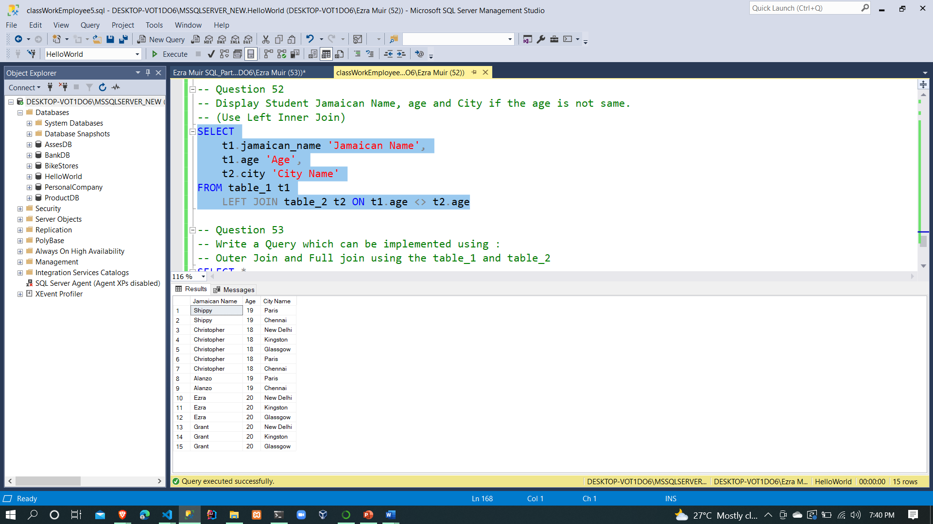

Question 53

SELECT *

FROM table_1 t1

FULL OUTER JOIN table_2 t2 ON t1.id = t2.id

